**Topic: Exploring IBM’s employees data set to derive human attrition causes**

**Loading Tables**

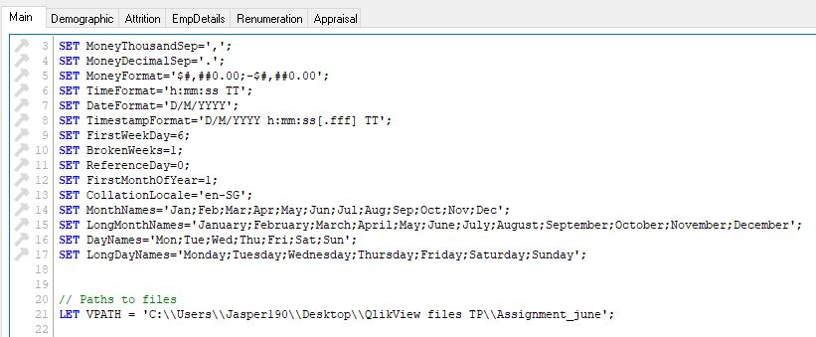

The project files were stored in a single folder, and in ‘main’ sheet, and VPATH variable was created to point to the source file folder, for separation of concerns, such that in the future, should a requirement come to update the data pool, it can be done easily

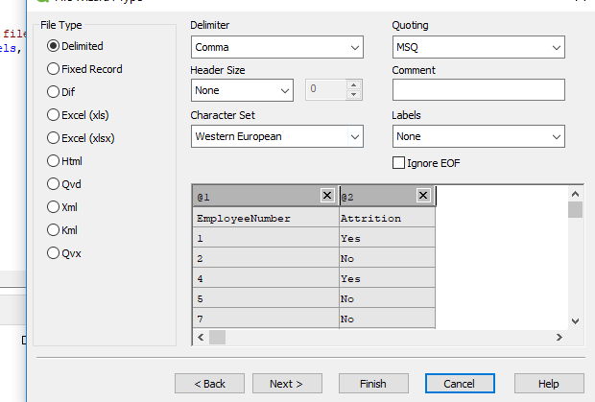

From the ‘Attrition’ csv file, there was a column of space at the top, but it was solved by changing ‘Labels’ to ‘Embedded Labels’

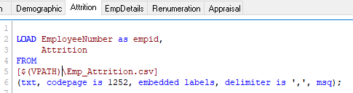

In the various files, the unique reference number for Employees was named ‘EmployeeNumber’ or ‘Employee_ID’, they were given an alias as EMPID to solve the non-unique Primary/Foreign key problem and allow the various tables to be joined via Primary Key- Foreign key

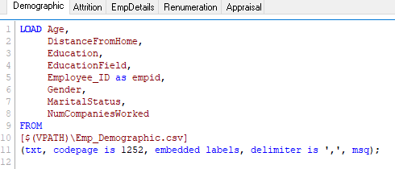

Similarly for Demographic, EMPID alias was used as primary key to the table

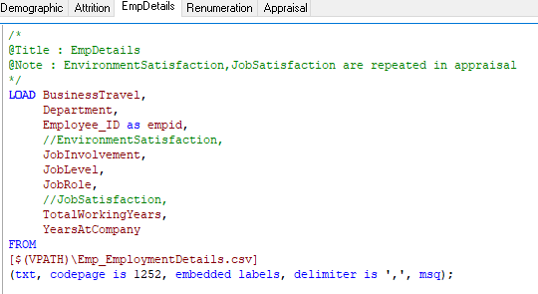

As for both ‘Employment Details’ and ‘Appraisal’ tables, there were synthetic keys, meaning keys not meant to be used as primary/foreign keys, they were commented out as shown above, ‘Environment Satisfaction’ , ‘Job Satisfaction’

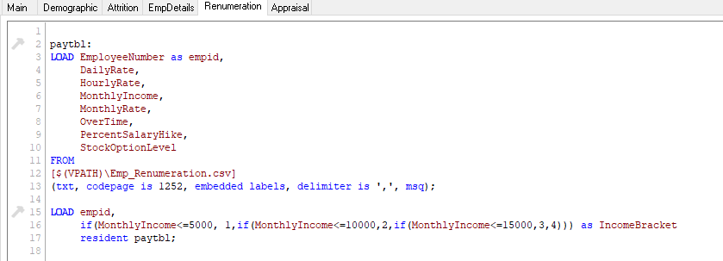

The files were all loaded from the working file, by Relative Path $(VPATH) which was found in main, and a new variable ’Income Bracket’ was created by using a temp table ‘PAYTBL’

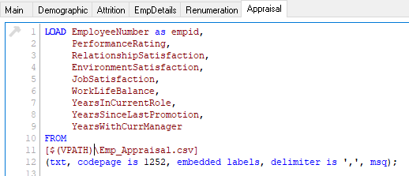

As the Synthetic keys were commented out in the ”EmpDetails” Table so other than the VPATH variable and EMPID changes, the columns were loaded as per normal

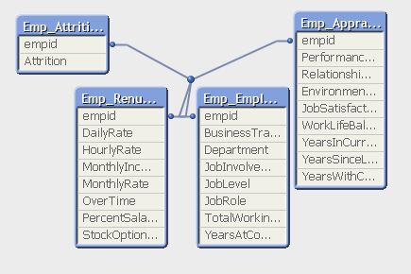

By removing the Synthetic Key, and renaming Employee unique identification numbers in the various tables to EMPID, we get the above Data Model and we are ready to start building the dashboard

**General Methodology**

To study the employee population targeting the Dependant Variable as Attrition rate, where Attrition=’Yes’, the aim is to reduce the attrition rate, as employees are valuable assets to the company which take time to train and nurture to become skilled and efficient at their role, which would ultimately increase the operating efficiency of the business

For that purpose, we group the factors into 3 clusters,

1. The Demography of the employees, or variables like Age, Gender, Marital Status, and education which are pre-disposed traits of the individual employees ( Sheet: Main )
2. External Factors like Environment, Manager Rating, Performance, Years worked, Years with same manager, No of companies worked for ( Sheet: Department )
3. Motivation Factors, like Salary ,Job Role, Job Position, Stock Option level and % Salary Hike were grouped together as Rewards ( Sheet: Reward )

I started off by grouping some common factors together, so that they could be cycled within the graph, like below,

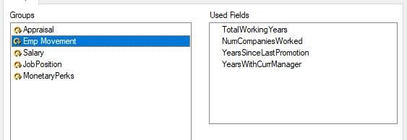

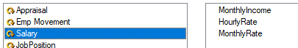

**Dashboard**

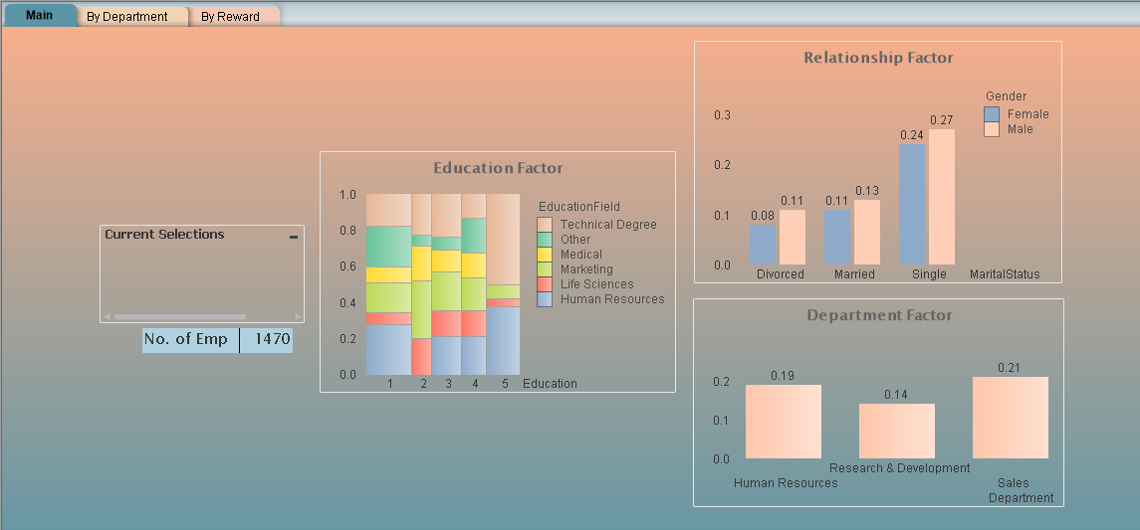

The first and main dashboard users will see is ‘Main’, which has a general overview of attrition rates across a various range of slices based on Employee Demography, meaning the pre-determined factors of the Employees,

The Y-axis is always Attrition Ratio, which is determined by ‘round(count({1<Attrition={Yes}>}empid)/count(empid),0.01) ’ or count of employees for the selection where ‘Attrition’ is yes, divided by total number of employees for the selection, we use ratios because the department segment sizes have di

The aim of such a format is to observe the different contributing factors to attrition rates

From left to right,

1. Below the current selections box, is the number of employees in the current selection, as the different slices have different sample sizes, the total number of employees for this study was 1470
2. In Education Factor, which a Mekko chart, education level 1 being the lowest and 5 the highest, we can identify that the more highly educated (5) technical degree people have a higher tendency of attrition as an overall trend, it could be suggested to target this group for a focused group engagement, especially since this group is highly specialized work, to find out what the root cause for their segment is, because there might be underlying factors
3. In Relationship factor, we see that for overall, singles are almost twice as likely to attrite than married or divorced people, so a suggestion would be to tie up with events from SDM to encourage employees to lead meaningful lives
4. From Department Factor, we see that for overall, Sales and HR have much higher rates of attrition

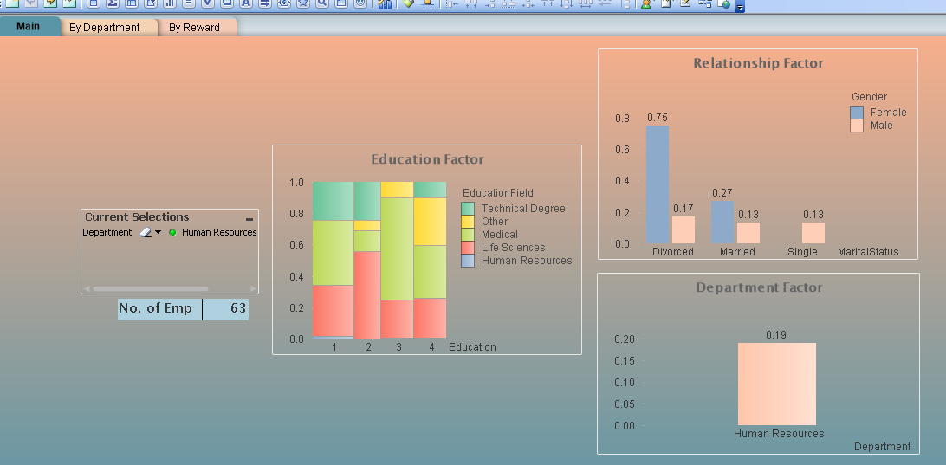

For example, we want to study why HR has a 0.19 attrition rate, we could possibly guess from the education factor table, that the employees took the role temporarily while looking for other opportunities, as the number of HR degree related attrition is quite low, only a thin line, and also in HR, which has 63 members, the highest rate of attrition comes from Divorced members, as seen from the Relationship factor, this could suggest that they lack support of someone to talk to at their workplaces, and possibly it could be contributing to a toxic culture, so a suggestion would be to outsource to an external counsellor vendor, or to build support networks for employees to vent their problems

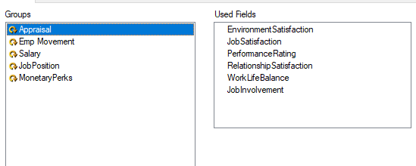

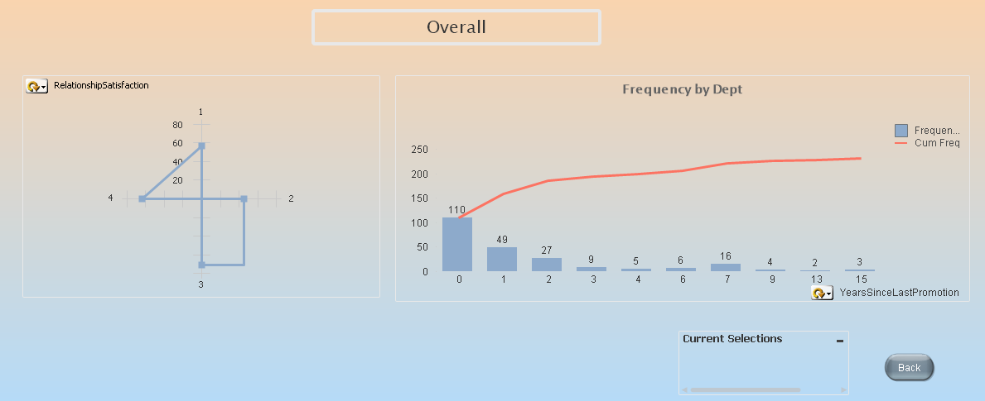

The next dashboard is ‘By Department’ which contains two cyclic graphs, where the cyclic is the ‘Appraisal’ group, the title of the page changes as per the group selection, and Departments can be studied by changing the option in the current selections box

From left to right,

1. On the left are external factors which are rated socially, by themselves, team members and their managers which do not have strong trends, because ratings 1 and 4 which are opposite ends of the spectrum, have lower attrition rates than those at 2 and 3, which could suggest that its not the top performers and the least performing who tend to attrite, but the middle Inter quartile range
2. For ‘Frequency by Dept’ graph, it is a cumulative frequency graph, and some interesting highlights are that people tend to attrite when they just got promoted, which suggests it gives them more bargaining power in moving to another role, but further studies need to be conducted to get a better idea on how to keep this group

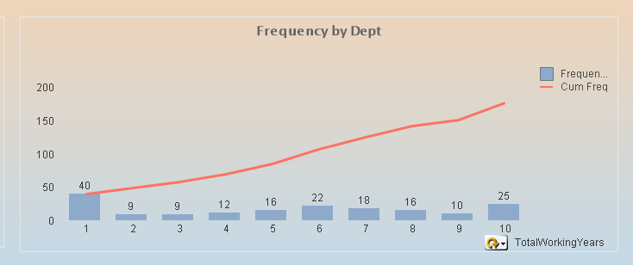

Also within this graph, by cycling through this, we see that employees in the initial stages of their careers tend to attrite more, but if they stay for 2 or more years, the attrition rate goes down by half, so one option would be to draft contracts of 2 years with penalty fees if they resign , or to design graduate programs of 2 years in length offering mentorship and other trainings, giving more pull factor for them to stay past the 1 year gap and we also observe that this effect increases and peaks at the 6th year, so shifting roles for those employees after 5 years might be a viable option

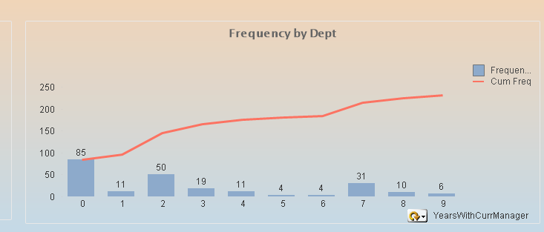

We can see that in a employee time span with their manager, the spike at 0 could be indicative of poor managerial skills, or friction between manager and employee, some training for managers would help to smooth the initial barrier, or possibly a mentorship program for new managers

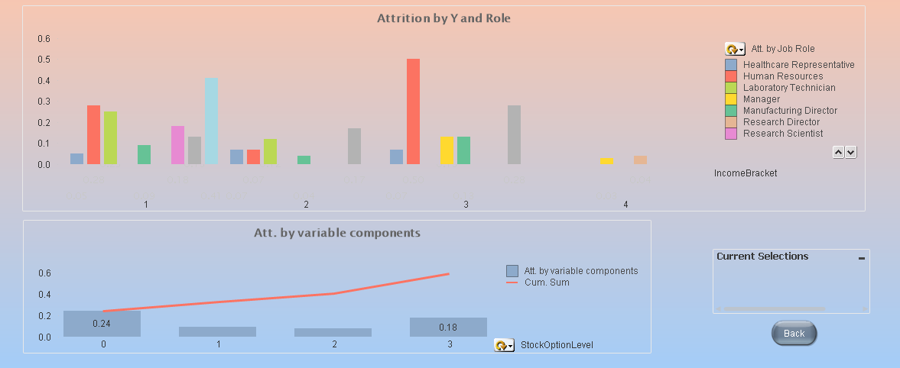

In the ‘By Reward ’ sheet,

From top to bottom,

1. On top, attrition by Y(income) and role, we can see that attritions are mostly from the junior roles, it could be indicative of poor mentorship or guidance , so developing training programs might help to lower the attrition rate at level 1
2. On the lower graph, it is a cumulative frequency graph of attrition by variable components such as stock option level and pay increase percentage, we can see for stock options level, if an employee own a share of the company, they are more inclined to stay and not attrite, so an option would be to give even junior employees a small share option percentage to attract them to stay and work harder for the firm

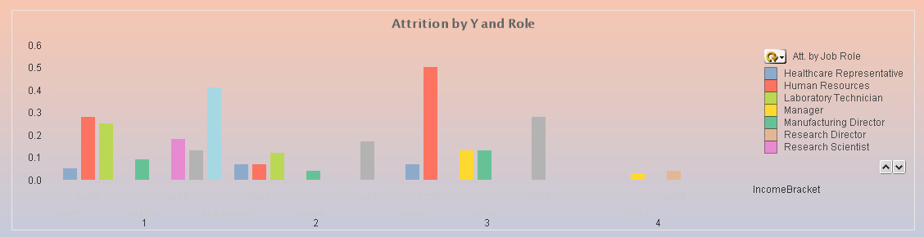

In the top graph, also (1), we can see that HR managers have a high attrition rate, it could be the effect of people coming and going such that the HR team does not form strong bonds, we could introduce ideas such as team lunches, or team learning sessions, or HR training to decrease the attrition rate

In conclusion, it can be said that it takes 20 percent effort to fix 80 percent of problems, if we can implement a comprehensive training and mentorship program, and smooth out the rough edges as mentioned above, we would have a better oiled operating team, which would be more bonded and stay longer, with less attrition rates